RULES AND REGULATIONS FOR HORSE SHOW

1. All classes shall follow W.H.A. rules.

2. Proper western attire must be worn. Youth exhibitors MUST wear protective headgear.

3. Lead Line Exhibitor: 18 years of age and under as of January 1st of the current year.

4. Youth may show in OPEN classes, BUT NOT senior classes.

5. Senior Exhibitor: 19 years of age and over as of January 1st of current year.

6. BIRTH CERTIFICATES REQUIRED FOR ALL YOUTH.

7. Classes with insufficient entries will be combined or cancelled at the discretion of the show committee.

8. Horse stalls are available for rent. Please contact the Board to reserve your request.

9. Overnight camping is permitted on the grounds free.

Donations are greatly appreciated.

For more information contact:
Don Thompson 705-723-5811

HIGHWAY DIRECTIONS

From Hwy 11 North, take exit 301 following the signs for Trout Creek. At the Flashing light (main intersection) in Trout Creek, turn left onto Hwy 522. Horse Show is part of the Trout Creek Fall Fair, located at the Arena grounds, on your left hand side, approximately 3 blocks.

From Hwy 11 South, take exit 305 following the signs for Trout Creek. At the flashing light (main intersection) in Trout Creek, turn right onto Hwy 522. Horse Show is part of the Trout Creek Fall Fair, located at the Arena grounds, on your left hand side, approximately 3 blocks.

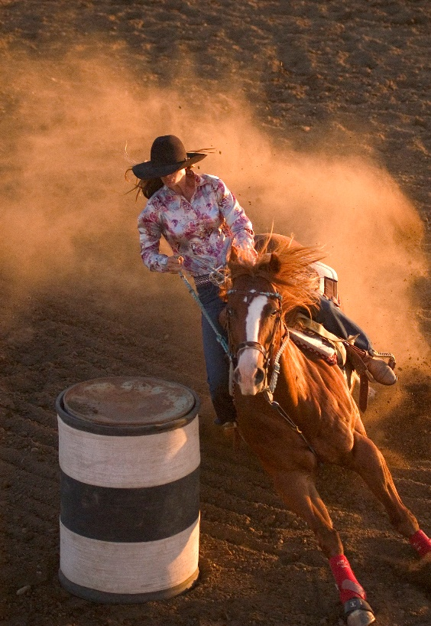

TROUT CREEK

FALL FAIR

HORSE SHOW

August 27th, 28th, 2022

ENTRY FEES

Lead Line No entry fee

Youth/Pony $5.00 per class

Senior $10.00 per class

Open Classes $10.00 per class

PAY BACK 80%

Lead Line Ribbons and Prizes

Fair Board Fee is five dollars ($5.00) for the weekend.

SATURDAY SUPPER

Saturday evening starting at 5:30 p.m. It is all you can eat for $15.00, 6-12 $8.00, 5 and under free. Upstairs in the arena.

PANCAKE BREAKFAST

Sunday morning starting at 7:30 a.m. all you can eat buffet breakfast $10.00 6-12 $8.00, 5 and under free.

CLASSES FOR HORSE SHOW
Shows starts at 8:00 a.m. Sharp!

 | Saturday Show
1. | Open Mares or Gelding
2. | Youth Showmanship
3. | Senior Showmanship
4. | Lead Line Walk/Jog
5. | Lead Line Barrels
6. | Youth Horsemanship
7. | Open Horsemanship
8. | Youth Western Pleasure
9. | Senior Western Pleasure
10. | Youth Hunter Under Saddle
11. | Senior Hunter Under Saddle
12. | Open English Equitation
13. | Open Western Equitation
14. | Open Command English or Western
15. | Open Pleasure Pairs
16. | Youth Trail
17. | Senior Trail
18. | Youth Stake
19. | Senior Stake
20. | Youth Pole Bending
21. | Senior Pole Bending
22. | Youth Flag Race
23. | Senior Flag Race
24. | Youth Barrel Race
25. | Senior Barrel Race
26. | Open Barrel Race
27. | Youth Dash for Cash
28. | Senior Dash for Cash
29. | Open Dash for Cash

CLASSES FOR HORSE SHOW
Shows starts at 8:00 a.m. Sharp!

 | Sunday Show
1. | Open Mares or Gelding
2. | Youth Showmanship
3. | Senior Showmanship
4. | Lead Line Walk/Jog
5. | Lead Line Barrels
6. | Youth Horsemanship
7. | Open Horsemanship
8. | Youth Western Pleasure
9. | Senior Western Pleasure
10. | Youth Hunter Under Saddle
11. | Senior Hunter Under Saddle
12. | Open English Equitation
13. | Open Western Equitation
14. | Open Command English or Western
15. | Open Pleasure Pairs
16. | Youth Trail
17. | Senior Trail
18. | Youth Stake
19. | Senior Stake
20. | Youth Pole Bending
21. | Senior Pole Bending
22. | Youth Flag Race
23. | Senior Flag Race
24. | Youth Barrel Race
25. | Senior Barrel Race
26. | Open Barrel Race
27. | Youth Dash for Cash
28. | Senior Dash for Cash
29. | Open Dash for Cash

